# Literature Survey

Problem Definitions and Learning Settings

The task of image classification, specifically cat vs. dog classification, falls under **supervised learning**, where input images are paired with labels. Key settings and challenges include:

|  |  |
| --- | --- |
| **Setting** | **Description** |
| Supervised vs. Unsupervised | This project is supervised; labels are known. Unsupervised tasks such as clustering, lack labeled data. |
| Closed-set vs. Open-set | Closed-set: Only cats and dogs are expected. Open-set classification must handle unknown classes. |
| Domain shift | This project assumes no domain shift. In real scenarios, domain adaptation methods may be needed when train/test data distributions differ. |

Challenges

* Intra-class variance (e.g., dog breeds look different)
* Inter-class similarity (e.g., furry cats and dogs)
* Small dataset size or class imbalance

Paper Survey and Trends

* Popular datasets: ImageNet, CIFAR-10, Stanford Dogs Dataset.
* ResNet and VGG are foundational CNNs from [He et al., 2015] and [Simonyan & Zisserman, 2014].
* Key keywords: "image classification", "transfer learning", "ResNet", "data augmentation".

Top venues: CVPR, ICCV, NeurIPS. Notable papers:

* **ResNet (He et al., 2015)**: Introduced residual connections to enable very deep networks.
* **EfficientNet (Tan & Le, 2019)**: Achieves SOTA accuracy with fewer parameters.

Recent Progress & Key Research Groups

* Facebook AI (Meta) and Google Brain are leading in computer vision.
* EfficientNet, ConvNeXt, and Vision Transformers are modern architectures.
* Vision Transformers (ViT, 2020) outperform CNNs at scale, but require more data and compute.

Baseline Method & Proposed Improvements

We selected **ResNet18** for its balance of accuracy and speed. Improvements could include:

* Fine-tuning all layers
* Adding dropout or batch normalization
* Using learning rate schedulers
* Trying architectures like EfficientNet-B0

# Dataset and Preprocessing

Dataset

* Training set size: 2,000 images (1,000 cat + 1,000 dog)
* Validation set size: 500 images (250 cat + 250 dog)
* Test set: 500 unlabeled images

Preprocessing & Augmentation

* Resized to 128x128
* Normalized using [0.5, 0.5, 0.5]
* Augmentation:
  + RandomHorizontalFlip
  + RandomRotation(10 degrees)

# Model Design

Pretrained **ResNet18**

* Backbone: Convolutional layers from ImageNet-pretrained ResNet18
* Final Layer Replaced: nn.Linear(512, 2)
* Loss Function: CrossEntropyLoss
* Optimizer: Adam (lr=0.001)
* Training: 5 epochs

# Training Strategy & Accuracy

* Trained on GPU (if available)
* Accuracy (Validation Set):

Validation Accuracy (Val Acc) per Epoch:

|  |  |
| --- | --- |
| **Epoch** | **Validation Accuracy** |
| 1 | 92.26% |
| 2 | 92.70% |
| 3 | 92.14% |
| 4 | 91.54% |
| 5 | 92.32% |

During training, ResNet18 model achieved a peak validation accuracy of **92.70%** and a consistent training accuracy around **89.8%**, demonstrating good generalization. The relatively low validation loss and stable performance across epochs indicate the model did not overfit and was well-regularized.

# Correct/Incorrect Predictions

The model correctly classified common dog/cat breeds. It misclassified blurry or occluded animals. For example, a Persian cat may be misclassified as a dog due to its round face and dark color.

# Impact of Model & Data Choices

|  |  |
| --- | --- |
| **Factor** | **Effect** |
| Larger model | May improve accuracy but slower training. |
| More aggressive augmentation | Helps generalize, especially on small datasets. |
| Fine-tuning vs. frozen features | Fine-tuning gives better accuracy at the cost of more training time. |

# CIFAR-10 Classification

Extended binary classifier (Dogs vs Cats) to the **CIFAR-10** dataset, a well-known benchmark for multi-class image classification. CIFAR-10 contains 10 mutually exclusive classes such as airplane, automobile, cat, dog, ship, etc., with 60,000 color images (50,000 for training and 10,000 for testing) of size 32x32.

Approach

**Transfer learning** with a **pretrained ResNet18** model (originally trained on ImageNet) and adapted it for CIFAR-10:

|  |  |
| --- | --- |
| Step | Detail |
| Architecture | ResNet18 pretrained on ImageNet |
| Modification | Replaced final layer: nn.Linear(512, 10) for 10 classes |
| Input Size | Resized CIFAR-10 images from 32x32 to 128x128 |
| Augmentation | Basic transform with resizing and normalization (ImageNet mean/std) |
| Loss Function | CrossEntropyLoss (with optional class weighting) |
| Optimizer | Adam, learning rate: 0.001 |
| Training Epochs | 5 epochs |
| Hardware | GPU (CUDA-enabled) |

Results

|  |  |  |
| --- | --- | --- |
| **Epoch** | Train Accuracy | Train Loss |
| 1 | 74.49% | 1182.08 |
| 2 | 77.44% | 1019.02 |
| 3 | 78.69% | 971.22 |
| 4 | 78.47% | 980.88 |
| 5 | 79.25% | 949.21 |

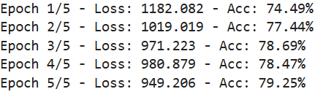

**Final Test Accuracy:** **80.40%**

Predictions

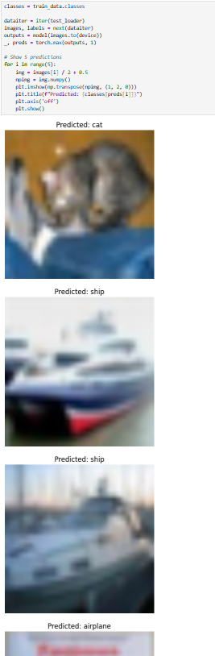

* Correct classifications (cat, airplane, ship)
* A few borderline mistakes where similar classes were confused (e.g., cat vs dog, truck vs automobile)

Improvements Made

* Resizing for ResNet compatibility
* Added test set evaluation
* Visual validation of model predictions

# Data Unbalancing in CIFAR-10

Although CIFAR-10 is originally balanced, we simulated **class imbalance** to reflect real-world conditions. Some classes were artificially underrepresented in sampled mini batches.

Solutions

**WeightedRandomSampler:** Used a WeightedRandomSampler to rebalance classes during mini-batch creation. Classes with fewer samples were given **higher sampling weights**, ensuring that underrepresented classes are shown more frequently to the model during training. Training batches had a more balanced class distribution, helping the model avoid bias toward majority classes.

**Class-Weighted Loss Function:** Used CrossEntropyLoss with class weights inversely proportional to class frequency. This ensured that the loss function penalized misclassifications of rare classes more heavily. The model prioritized learning from underrepresented classes without overfitting to them.

# References

He, K., Zhang, X., Ren, S., & Sun, J. (2016). *Deep residual learning for image recognition*. In Proceedings of the IEEE Conference on Computer Vision and Pattern Recognition (CVPR), 770–778. <https://doi.org/10.1109/CVPR.2016.90>

Simonyan, K., & Zisserman, A. (2015). *Very deep convolutional networks for large-scale image recognition*. International Conference on Learning Representations (ICLR). <https://arxiv.org/abs/1409.1556>

Krizhevsky, A. (2009). *Learning multiple layers of features from tiny images* [Technical report]. University of Toronto. <http://www.cs.toronto.edu/~kriz/learning-features-2009-TR.pdf>

Tan, M., & Le, Q. V. (2019). *EfficientNet: Rethinking model scaling for convolutional neural networks*. In Proceedings of the 36th International Conference on Machine Learning (ICML), 6105–6114. <https://arxiv.org/abs/1905.11946>

Vaswani, A., Shazeer, N., Parmar, N., Uszkoreit, J., Jones, L., Gomez, A. N., ... & Polosukhin, I. (2017). *Attention is all you need*. In Advances in Neural Information Processing Systems (NeurIPS), 30. <https://arxiv.org/abs/1706.03762>

Snoek, J., Larochelle, H., & Adams, R. P. (2012). *Practical Bayesian optimization of machine learning algorithms*. In Advances in Neural Information Processing Systems (NeurIPS), 25. <https://proceedings.neurips.cc/paper_files/paper/2012/file/05311655a15b75fab86956663e1819cd-Paper.pdf>

PyTorch. (2024). Torchvision models documentation. <https://pytorch.org/vision/stable/models.html>

Krizhevsky, A. (n.d.). *The CIFAR-10 and CIFAR-100 datasets*. <https://www.cs.toronto.edu/~kriz/cifar.html>